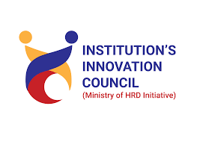

AMBALIKA INSTITUTE OF MANAGEMENT AND TECHNOLOGY

MOHANLALGANJ, LUCKNOW

POST EVENT SUMMARY
Name of Event: Workshop on Total Station.
Date of Event: 20th April 2023
Duration: 5 Hours
Location of Event: Institute.
Number of Internal participants:
No. of Students: 18
No of Faculties: 2
Mode of Session: Offline
Keynote Speaker (if any): Mr. Brajraj Yadav.
Objective of event: Working and Application of Total Station in Engineering Surveying.
Summary of Event (Approx. 100 words):
Total Stations are mainly used by Civil Engineers and Land Surveyors, either to record features as in Topographic surveying or to set out features (such as roads, houses, boundaries). Total Stations are also used by Archaeologists to record Excavations. Total station is used for measuring Slant distances, horizontal and Vertical Angles, and elevations in topographic and geodetic works, tachometric surveys as well as for solution of application geodetic tasks.
This workshop makes students aware of surveying using Total Station and input the result of Total Station to computer using computer software’s for drafting and make efficient to students to work in surveying.
SOME GLIMPSES OF THE EVENT(Photographs):
